**How to install *Microsoft Visual Studio Express 2013***

* Download Microsoft Visual Studio Express 2013

http://www.visualstudio.com/downloads/download-visual-studio-vs#d-express-windows-desktop

NB: You must have a MicrosoftAccount…if you don’t have it you can create your account during the procedure

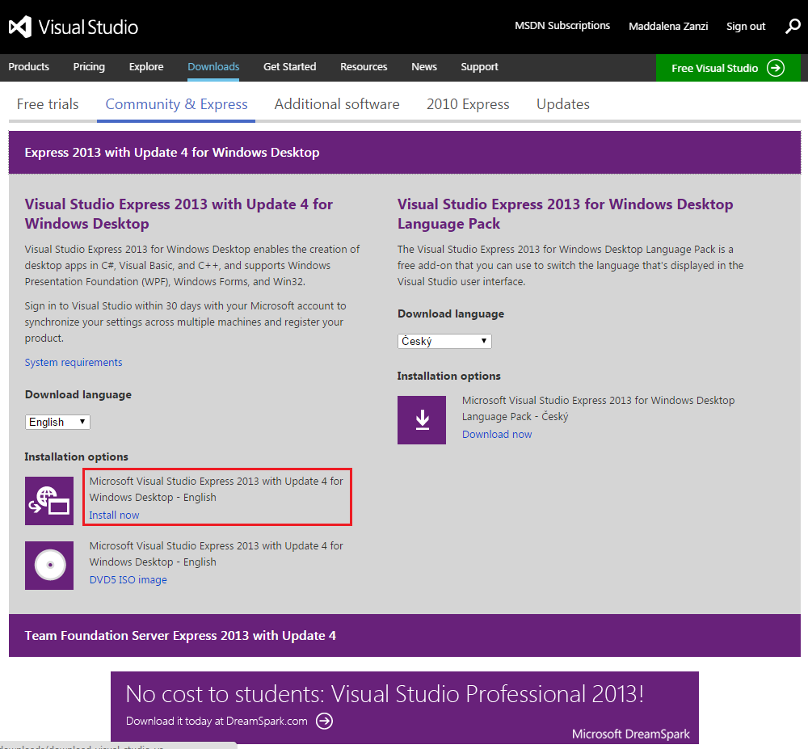

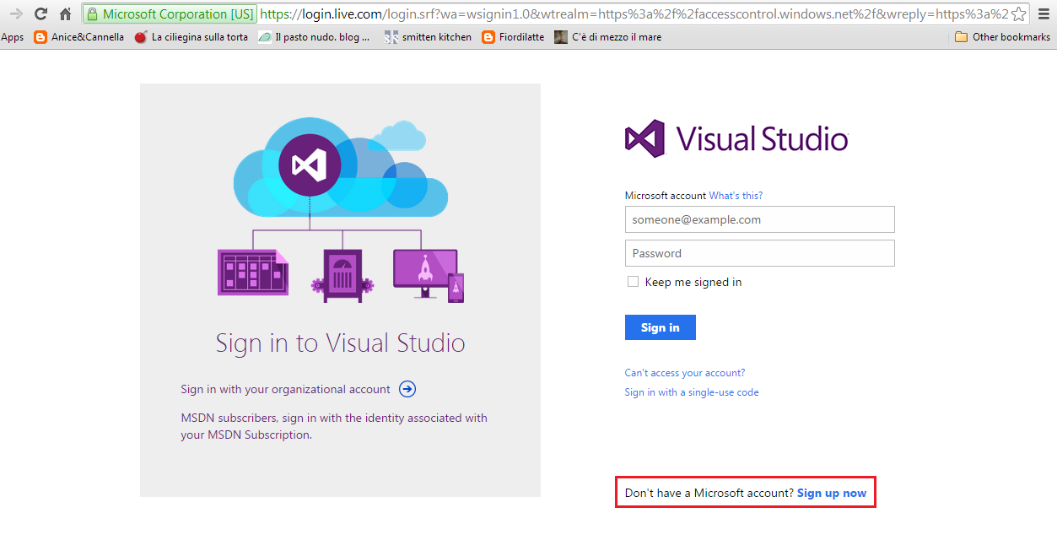

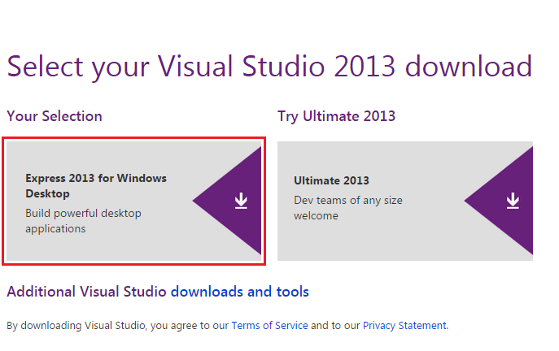

* Execute *wdexpress_full.exe,* follow the installation wizard and, at the end of the procedure, launch VisualStudio

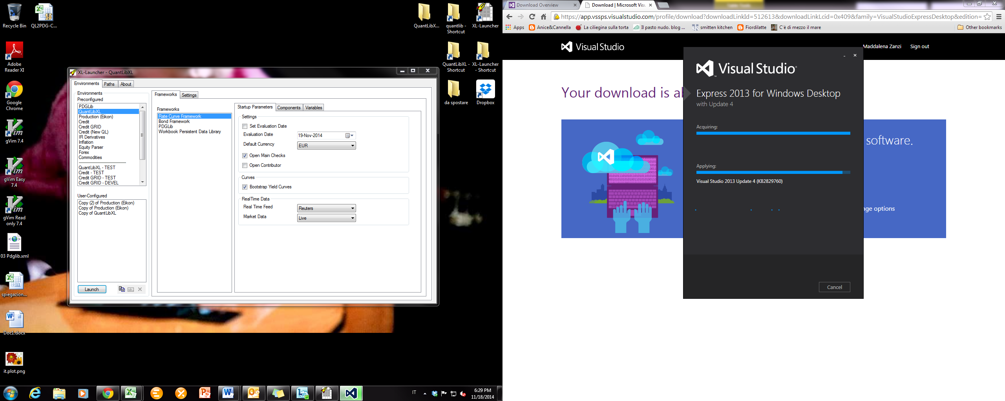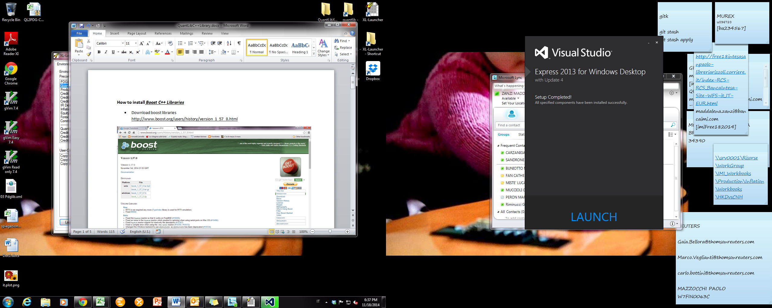

**How to install *Boost C++ Libraries***

* Download latest boost libraries (1.58 at time of writing) <http://www.boost.org/users/download/>
* Unzip *boost_1_58_0.zip* (or better *boost_1_58_0.7z* if you have 7z) in your preferred folder

1. run Developer Commad Prompt for VS2013 (or a generic command prompt if you have just one compiler installed on your workstation) and move to the boost folder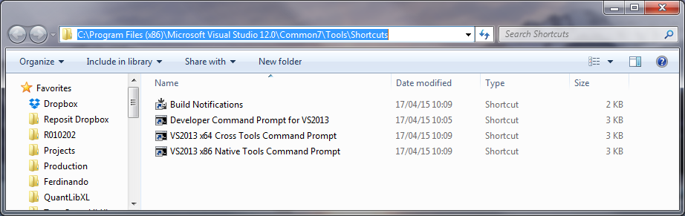

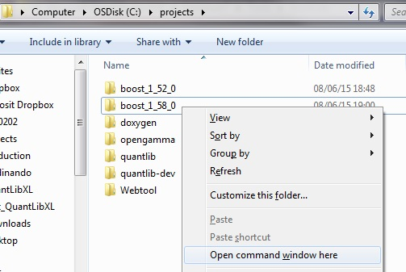

1. Execute the following commands (j4 is for using 4 threads: up to you and your CPU how many):
   * bootstrap.bat
   * b2 toolset=msvc-12.0 --build-type=complete install -j4

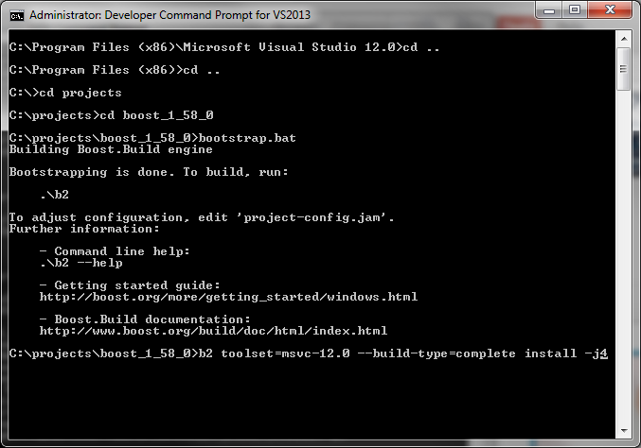

1. If you also want to compile for x64, move all win32 libraries just created in C:\Boost\lib into C:\Boost\lib**\win32**, then remove the boost_1_52_0\bin.v2 folder and execute the following commands:
   * bootstrap.bat
   * b2 toolset=msvc-12.0 **address-model=64** --build-type=complete install -j4
2. Now move the x64 libraries just created in C:\Boost\lib into C:\Boost\lib**\x64**
3. Iterate 1-4 for any other compiler you want to use

**How to get your *QuantLib Repository***

* Go to <https://github.com/> and create your account

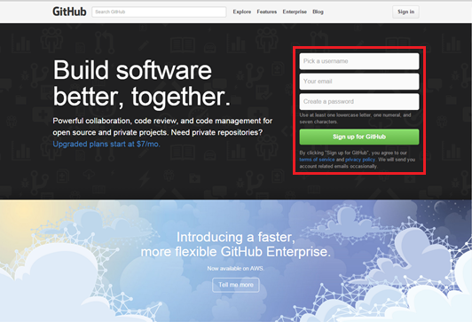

* Go to https://github.com/fametrano/quantlib and press *Fork*

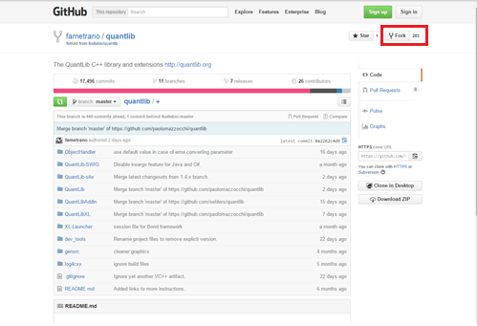

* Go to msysgit.github.io and download the program;

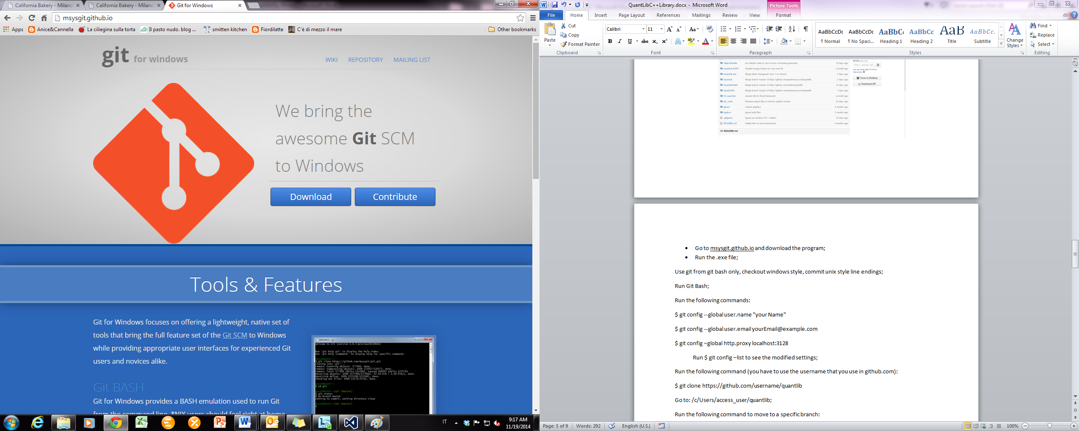

* Run the .*exe* file;
* Follow the installation Wizard selecting this options:
  + Use git from git bash only, checkout windows style, commit unix style line endings
* Run Git Bash
* Run the following commands:
  + $ git config --global user.name "*your Name*"
  + $ git config --global user.email *yourEmail*@*example.com*
* Run $ git config –list to see the modified settings
* Run the following command (you have to use the username that you use in github.com):

$ git clone https://github.com/*username*/quantlib

* Close Git Bash
* Right click on your quantlib folder and select “Git Bash”

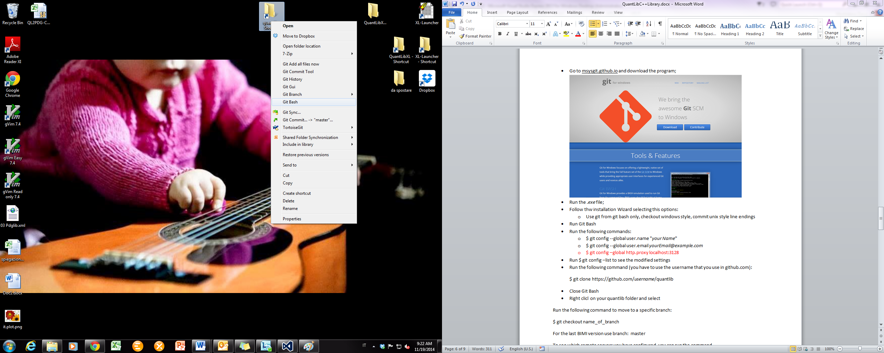

* Run the following command to move to a specific branch:

$ git checkout *branchname*

For the last BIMI version use branch *master*

* To see which remote servers you have configured, you can run the command

$ git remote –v

* To add a remote server you can run the command

$ git remote add *remote_server_shortname* *remote_server_url*

(for example: $ git remote add ferdinando https://github.com/fametrano/quantlib)

* You can use the command

$ git pull remote_server_shortname *branchname*

to automatically fetch and then merge a remote branch into your current branch

(for example: $ git pull ferdinando master)

**How to build your *QuantLibXL Library***

1. Open VisualStudio Express2013 and load *QuantLibXL_full_vc12.sln* project (you can find it in your quantlib repository in *QuantLibXL* folder)

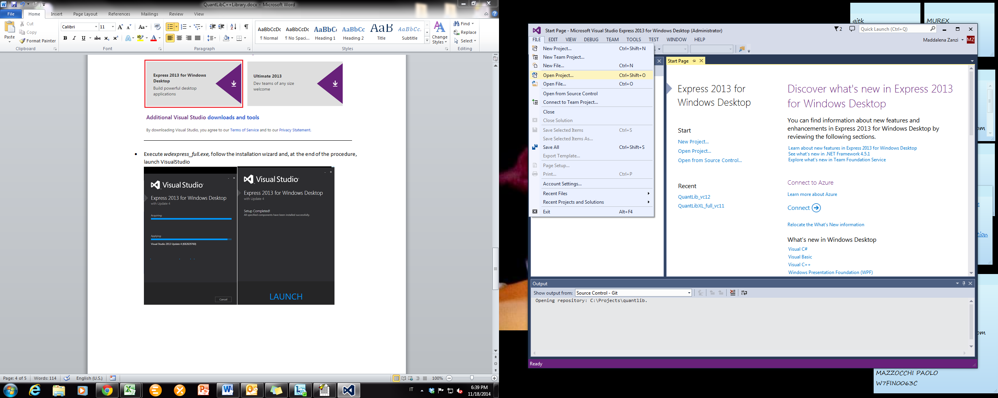

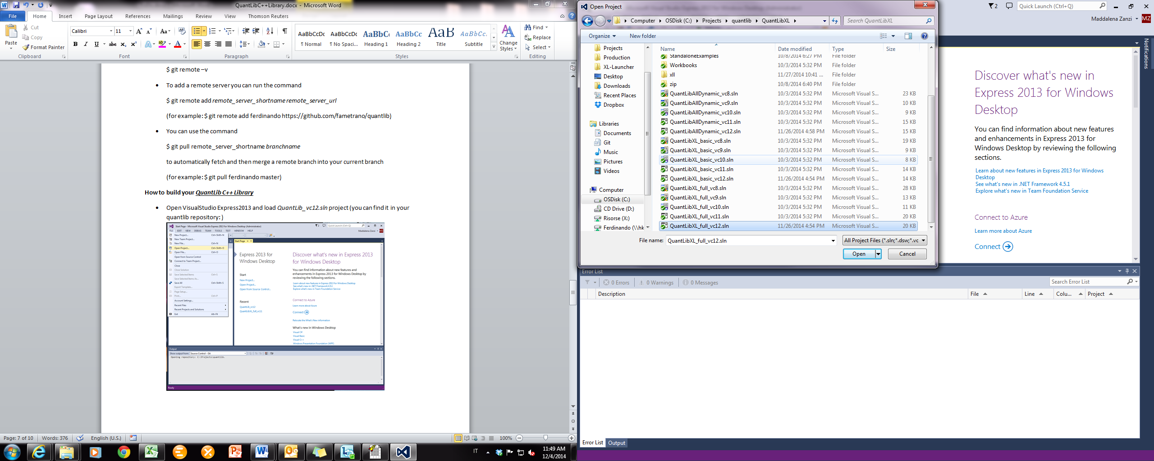

1. Set the configuration *Release (static runtime)* for the platform *Win32*

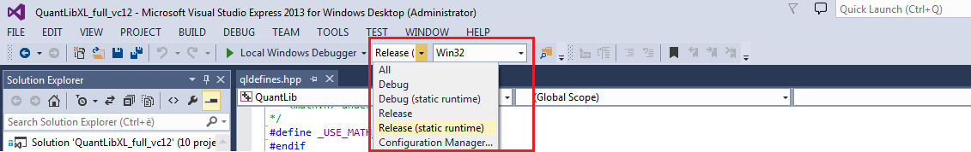

1. Open the Property Manager (View🡪Other Windows🡪Property Manager)

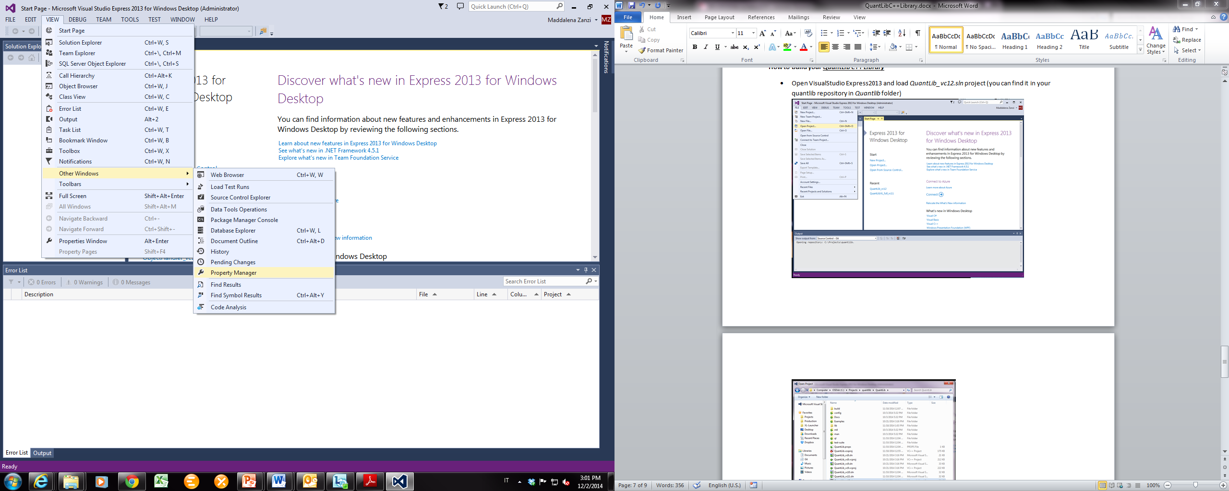

1. Right Click on

*QuantLib*🡪*Release|Win32*🡪*Microsoft.Cpp.Win32.user*

and open *Properties* Window

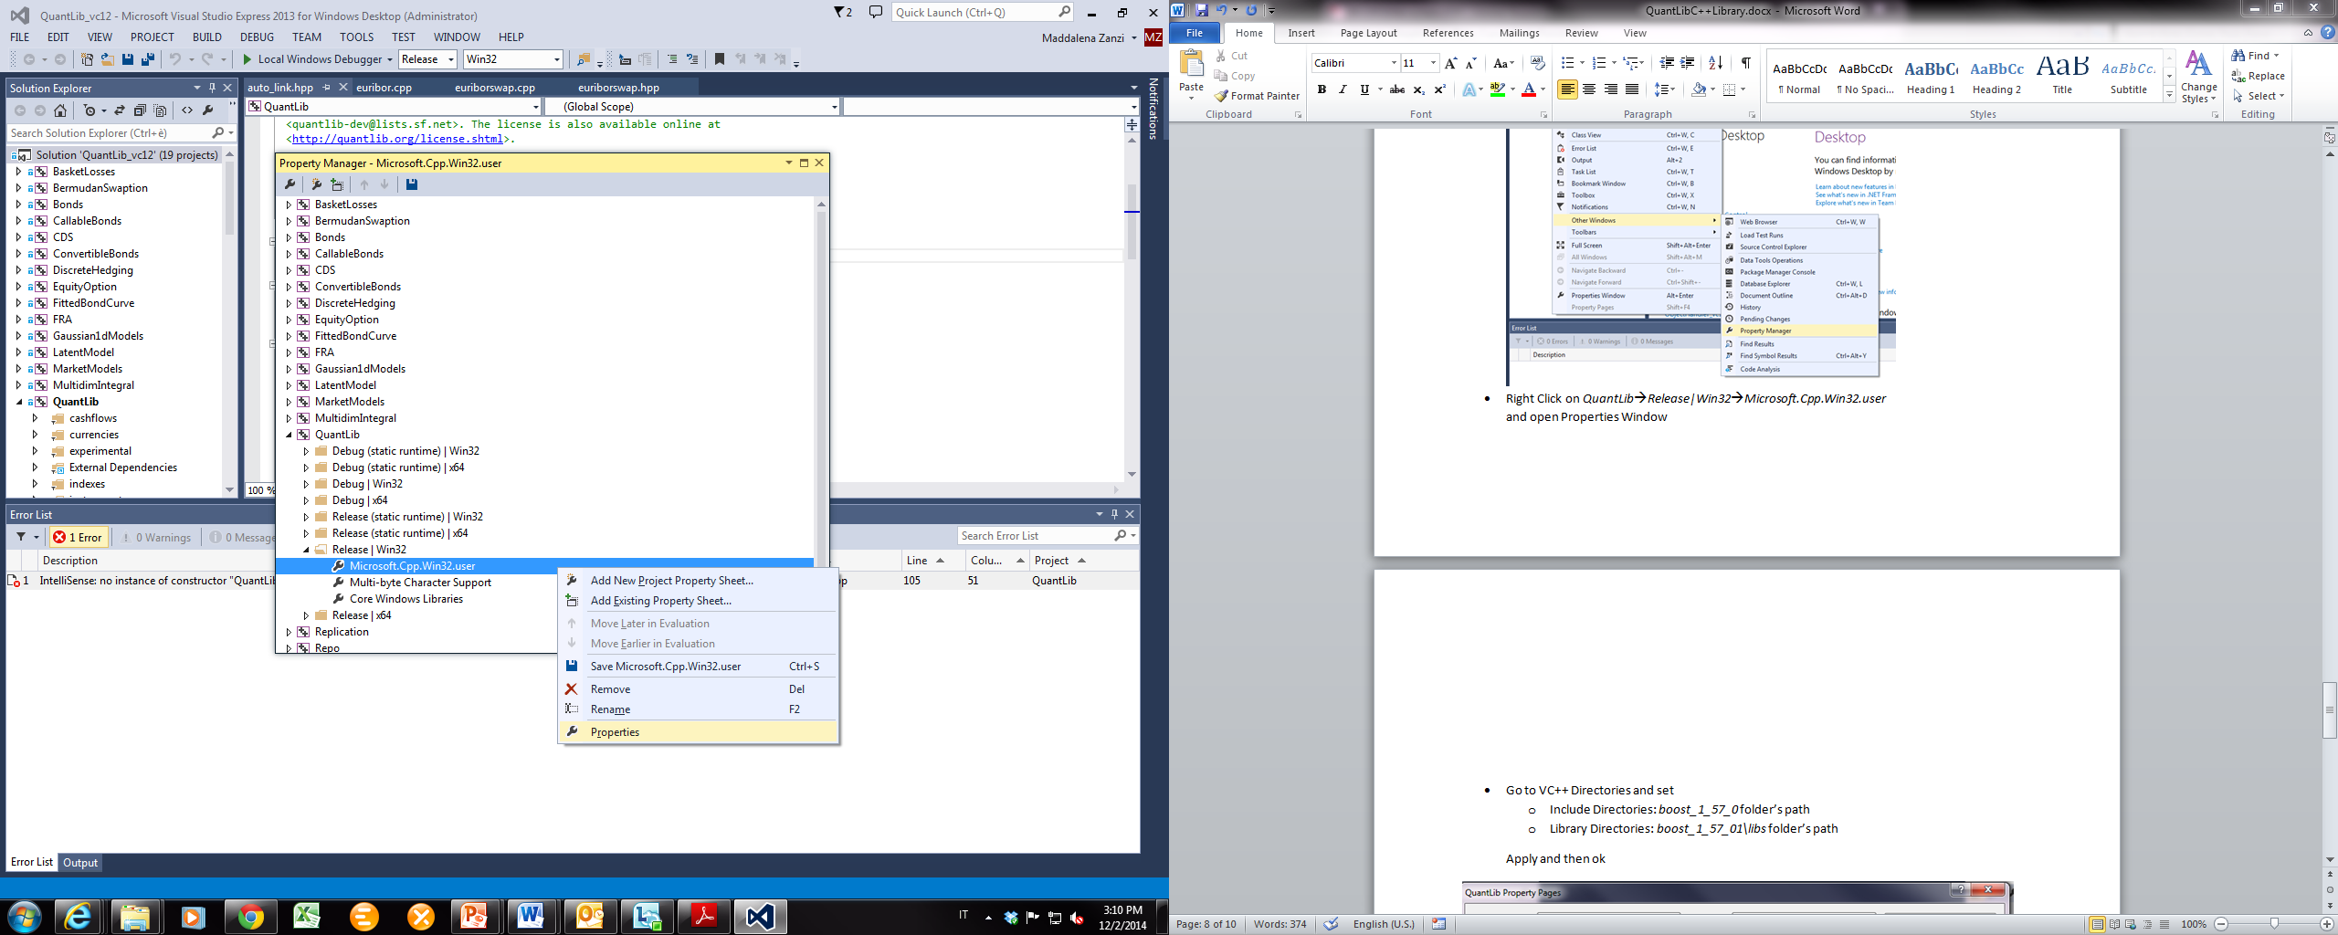

1. Go to *VC++ Directories* and set
   1. Include Directories: C:\Boost\include\boost-1_58
   2. Library Directories: C:\Boost\lib (or C:\Boost\lib**\win32**)
   3. Apply and then OK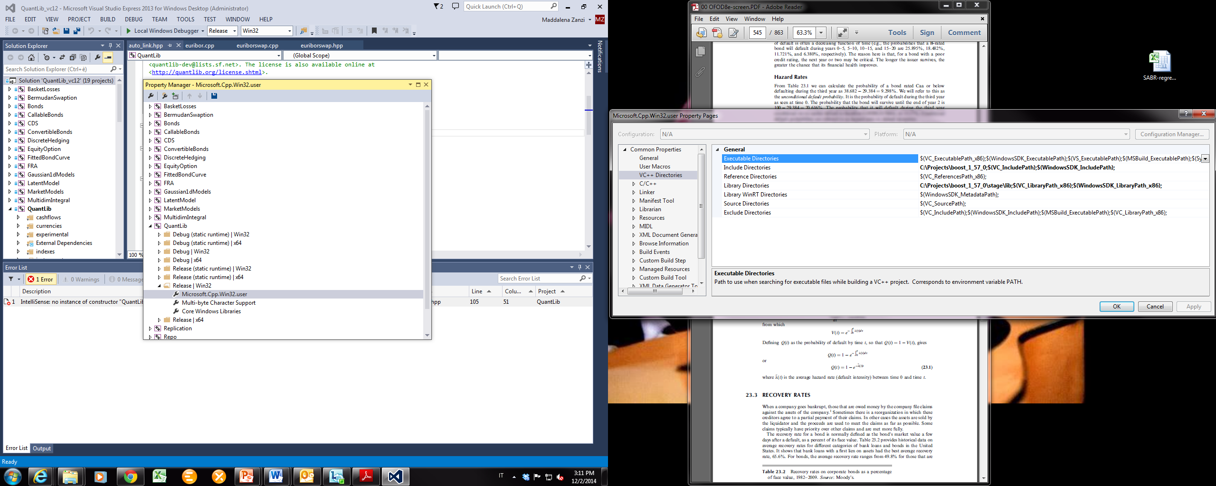

*NB: if you also have the x64 target you have to repeat the directories’ setting for it*

* + *Open the Property Manager (View🡪Other Windows🡪Property Manager)*
  + *Right Click on*

*QuantLib🡪Release|x64🡪Microsoft.Cpp.x64.user*

*and open Properties Window*

* + *Go to VC++ Directories and set*
    - Include Directories: C:\Boost\include\boost-1_58
    - Library Directories: C:\Boost\lib**\x64**
  + *Apply and then OK*

1. Build the soultion and wait until the end of the procedure

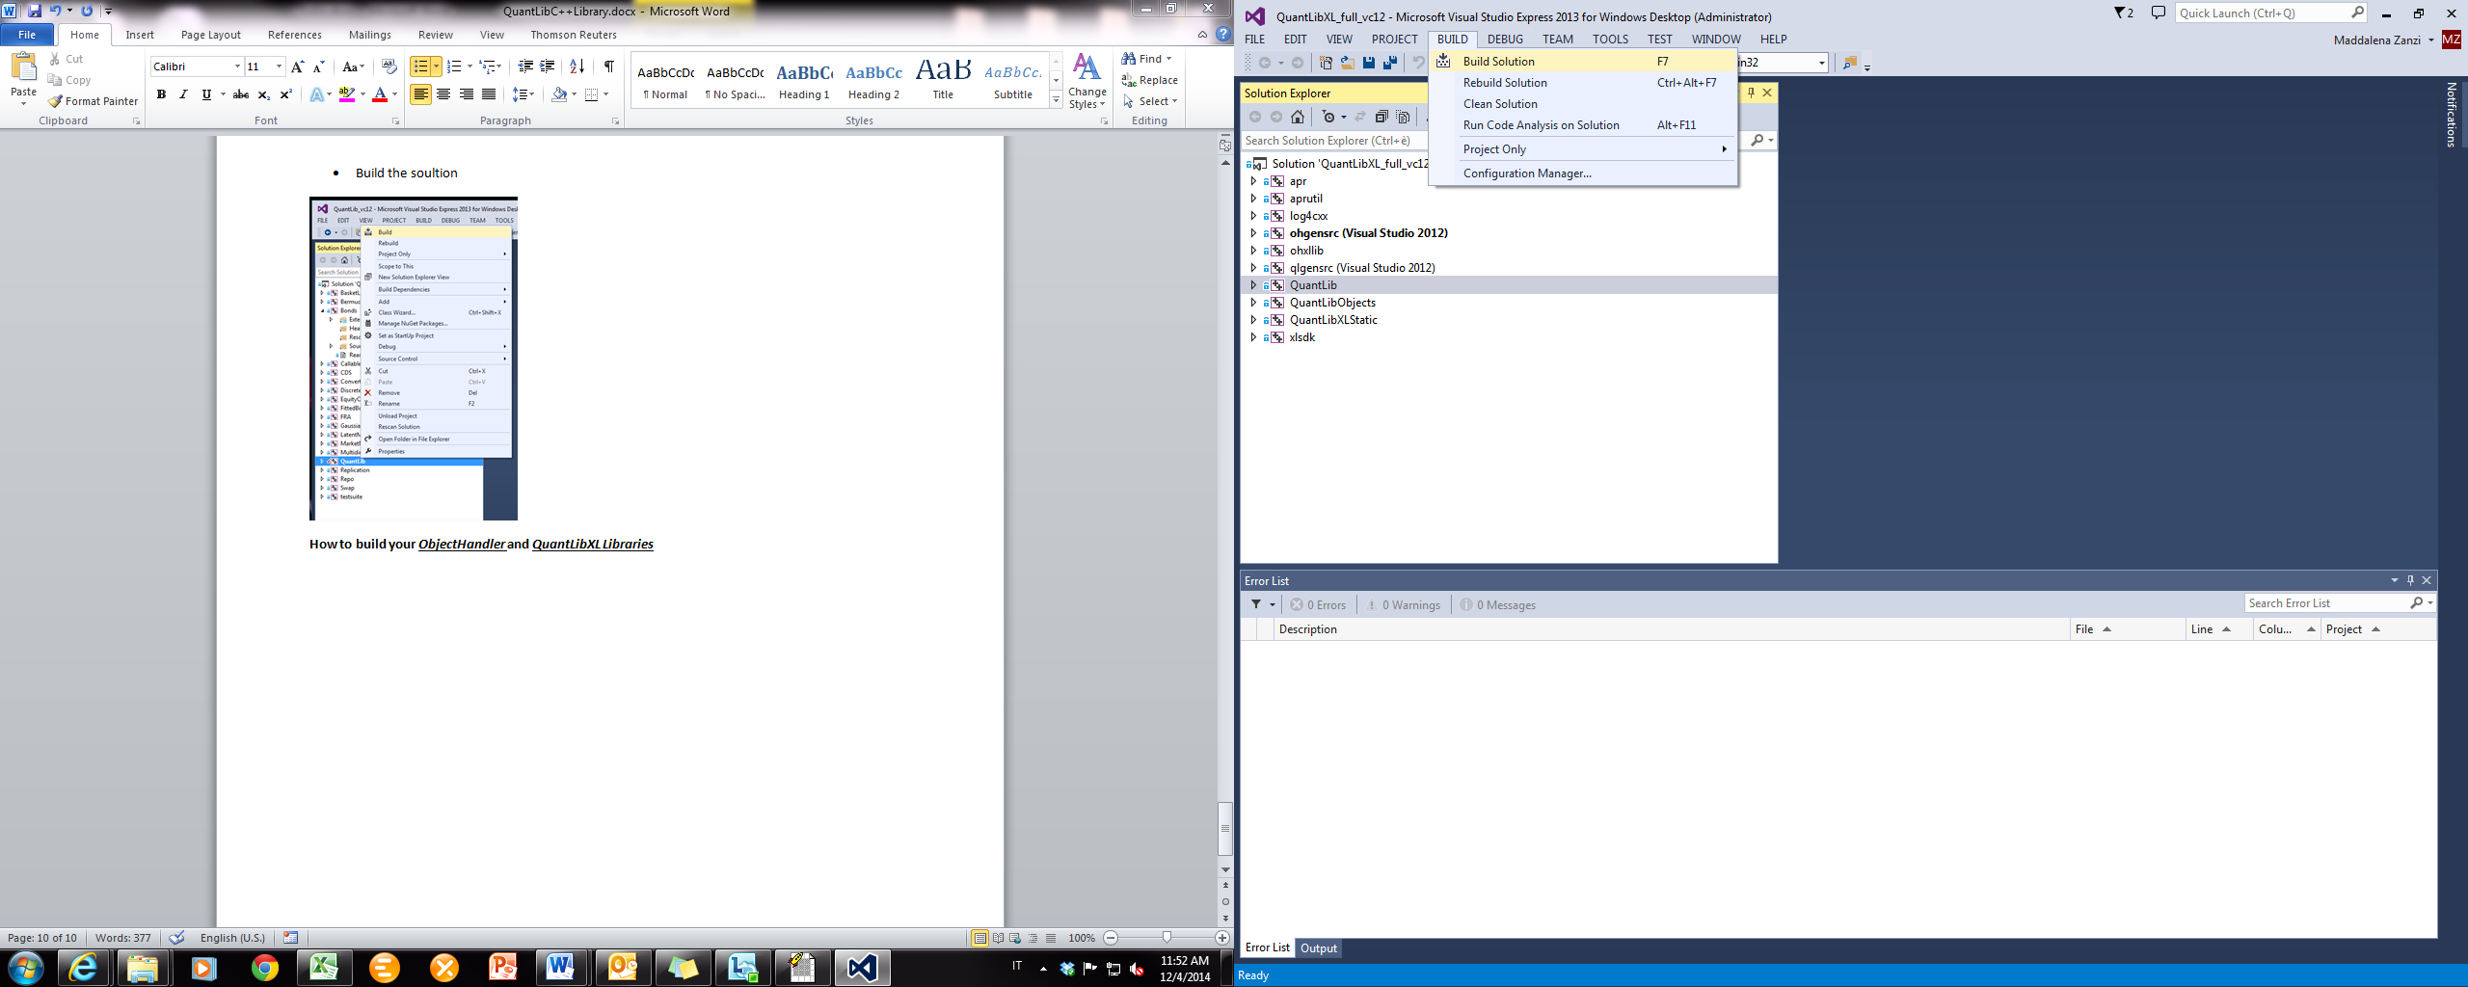

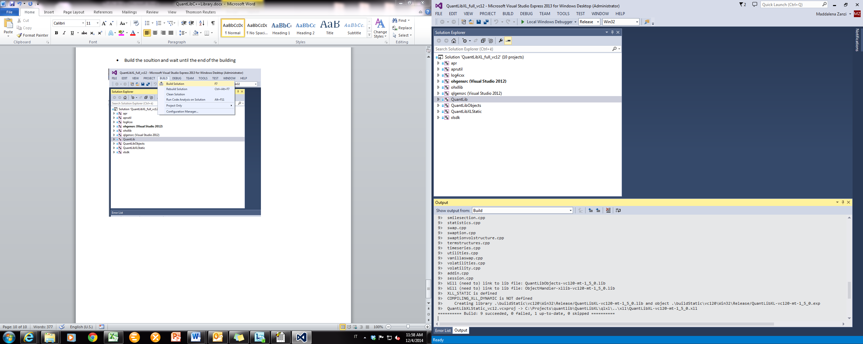

1. If the building ends succesfully you will find *QuantLibXL-vc120-mt-s-1_5_0.xll* in your quantlib repository (path *\QuantLibXL\xll*) and you will be able to open it in a new EXCEL session

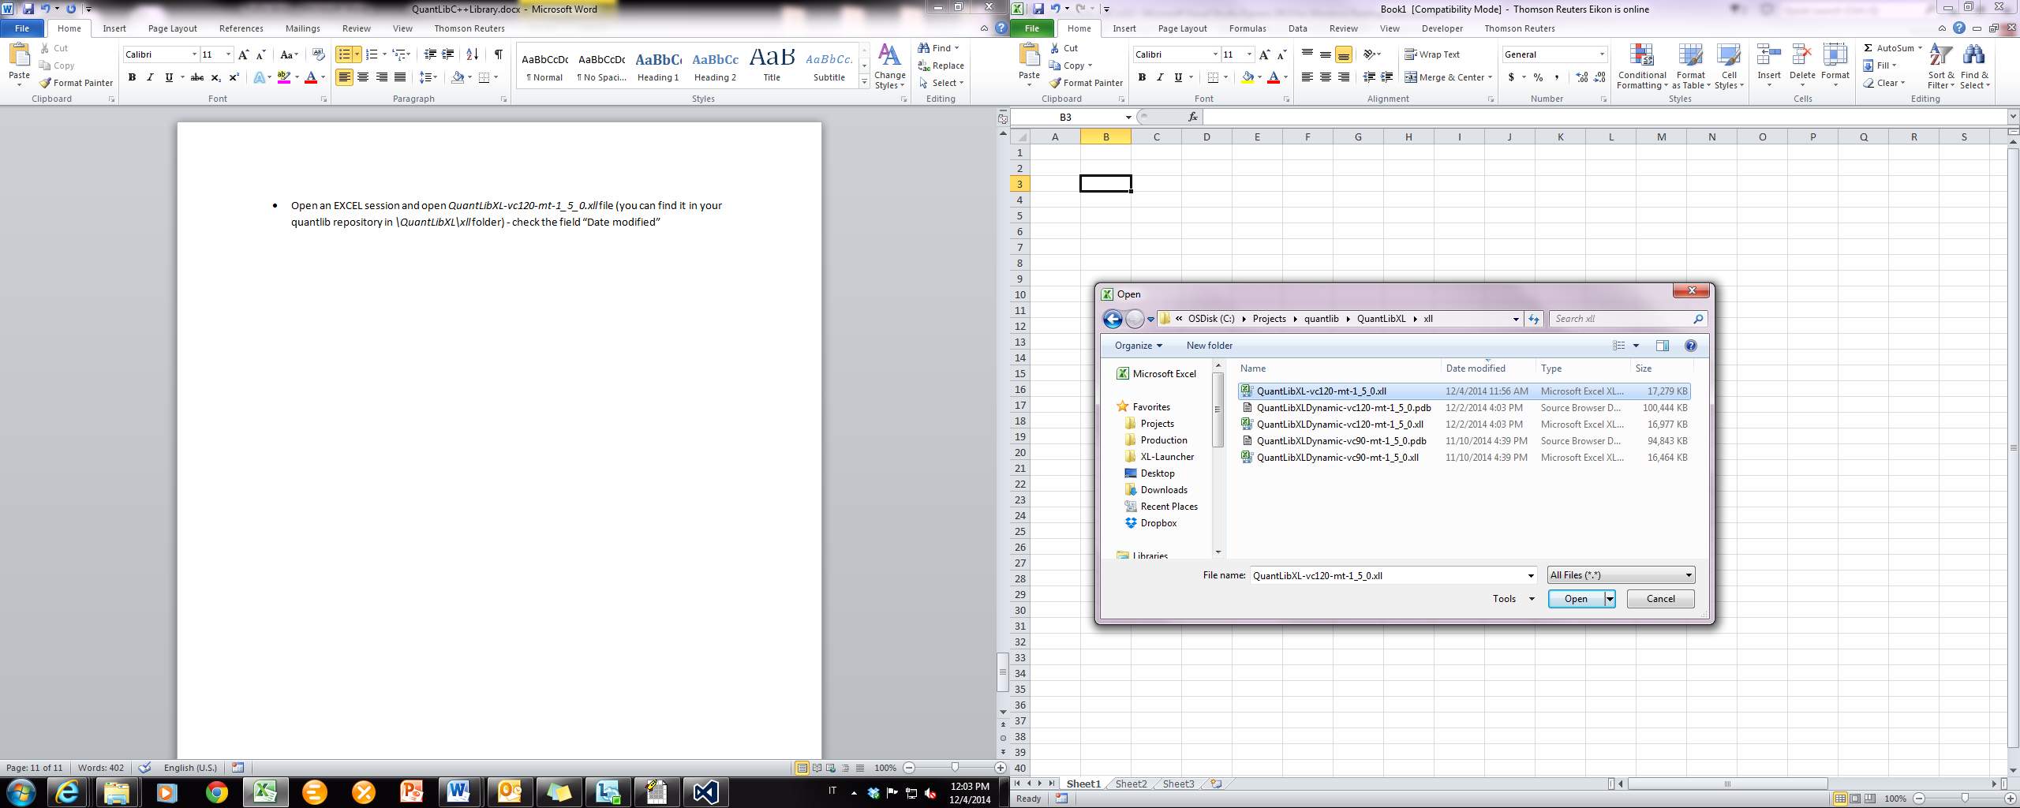

1. Set the configuration *Release* for the platform *Win32*



1. Repeat step 6
2. If the building ends succesfully you will find *QuantLibXL-vc120-mt-1_5_0.xll* in your quantlib repository (path *\QuantLibXL\xll*) and you will be able to open it in a new EXCEL session
3. Now you are ready to use QuantLib (an ObjectHandler) functions in EXCEL environment!

